**Full Stack Development with MERN**

**Frontend Development Report**

|  |  |
| --- | --- |
| Date | 12th July 2024 |
| Team ID | SWTID1720075176 |
| Project Name | Online Complaint Registration Application |
| Maximum Marks |  |

**Project Title: Online Complaint Registration Application**

Date: 12th July 2024

Prepared by: Mithunraj M, Mohith G K, Spoorthi N, Piyush.

**Objective**

The objective of this report is to document the frontend development progress and key aspects of the user interface implementation for the Online Complaint Registration for societal issues project.

**Technologies Used**

* **Frontend Framework:** React.js
* **UI Framework/Libraries:** Bootstrap, tailwind css
* **API Libraries:** Express, Mongoose, cors, body-parser, multer, axios

**Project Structure**

**1.Home Page:**

It contains the signup and login portal and also a short and brief description of the motive of the application. Count of the no of visitors and complaints registered are displayed here for viewing . It consists of the navbar which allows us to navigate to the different pages of the application.

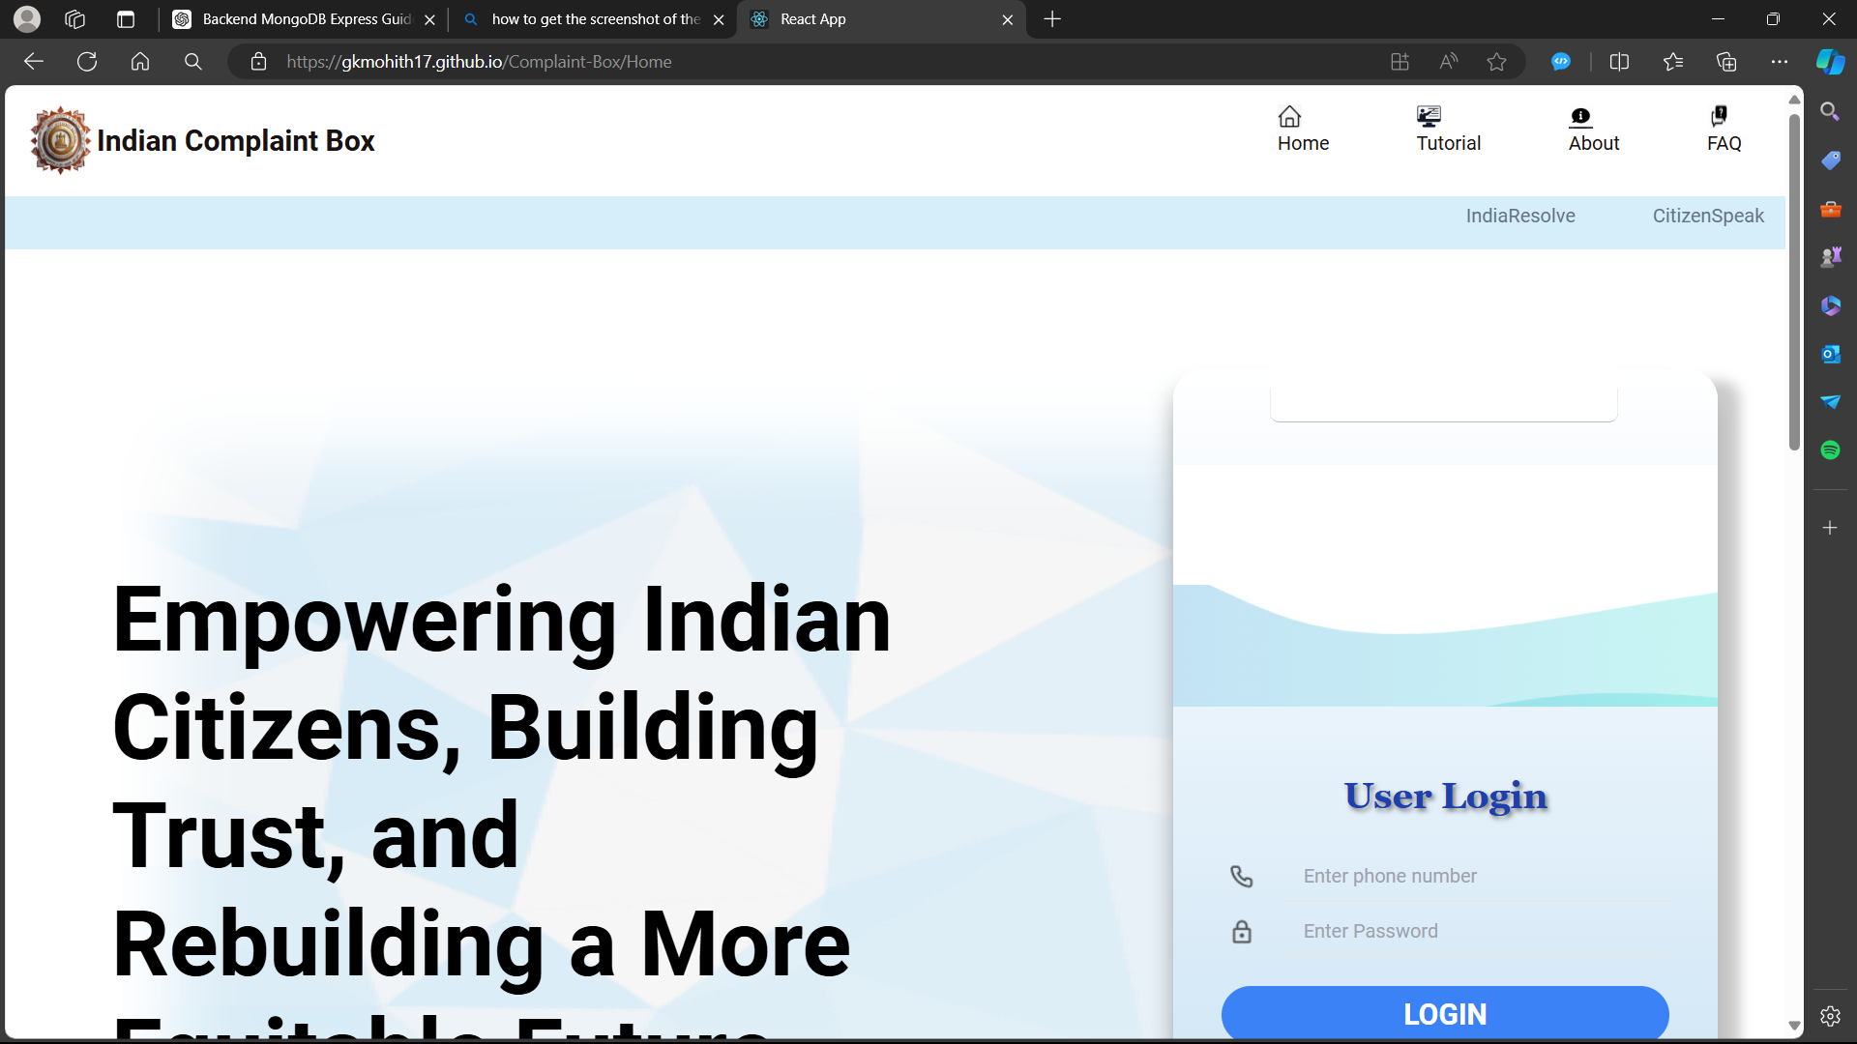

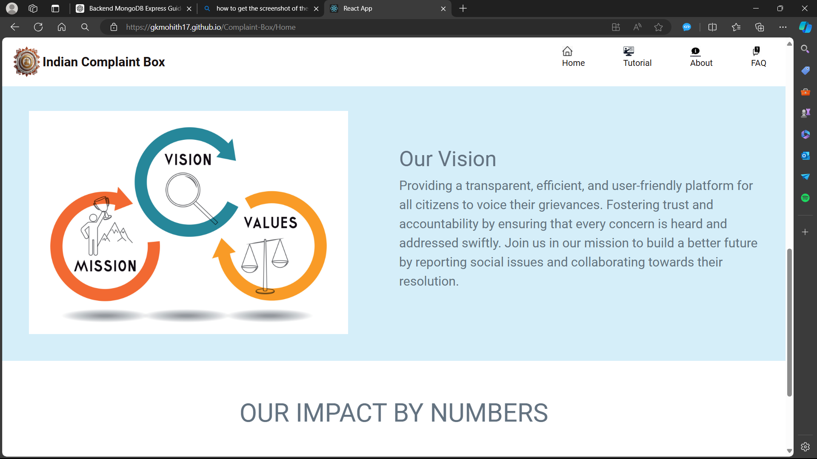

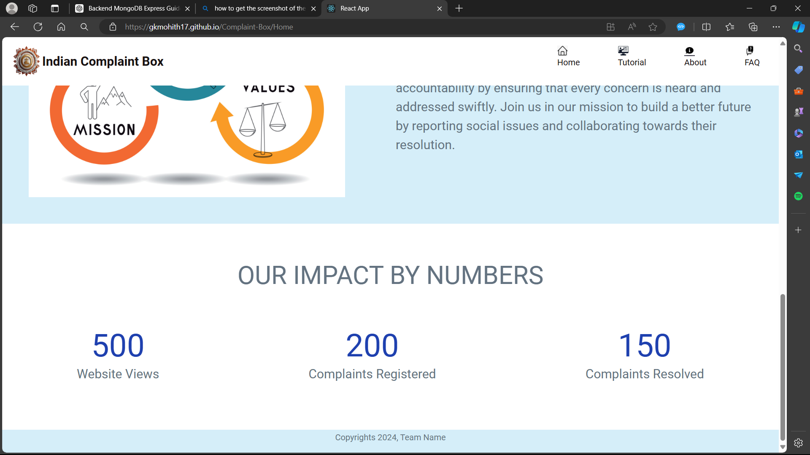

**2. About us Page:**

It describes the root motive and policy of the organization . A timeline showing the steps to be taken to use the application is implemented for user understanding. Contact information is presented here for the users to contact the authorities or the technical team in case of need of assistance.

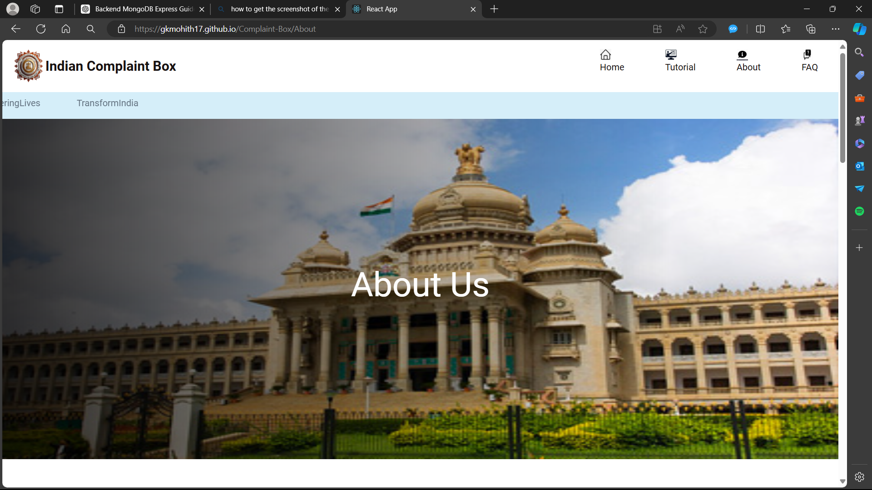

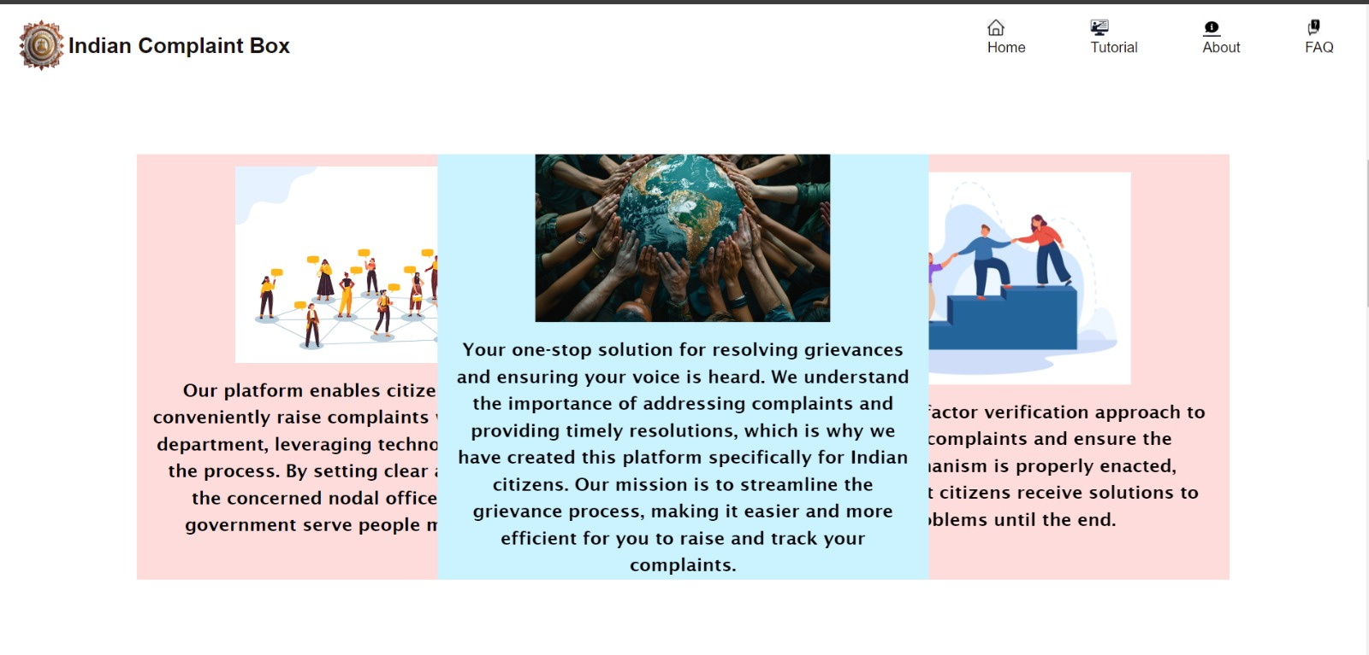

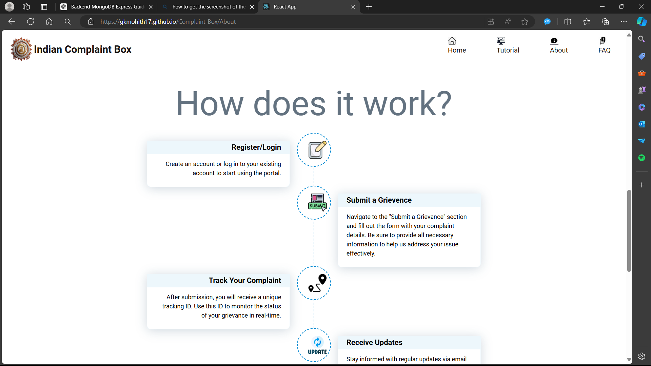



**3. Tutorial Page:** This page contains the information and guidelines necessary to use the application in effective manner. It is incorporated with a step by step guide for the user.

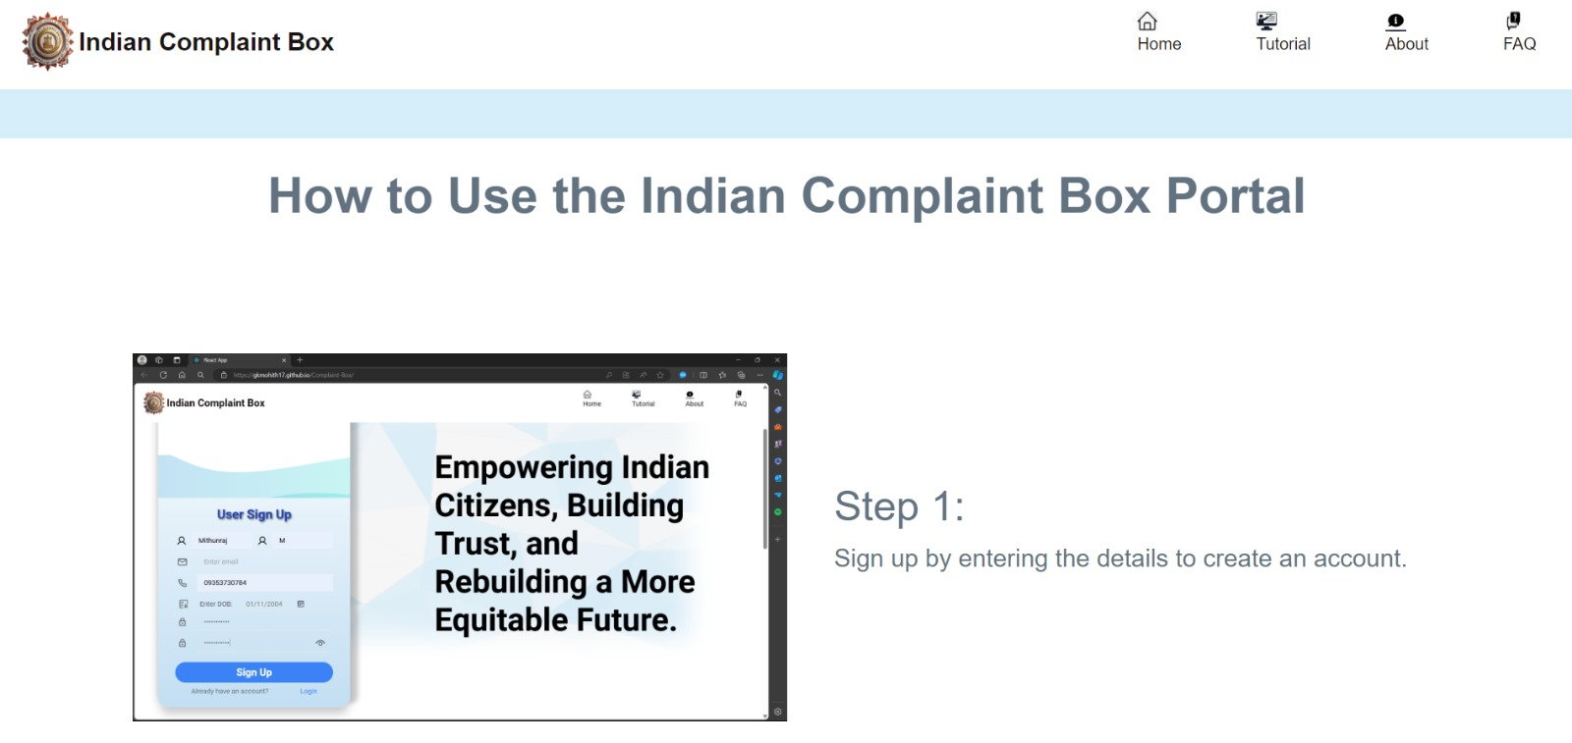

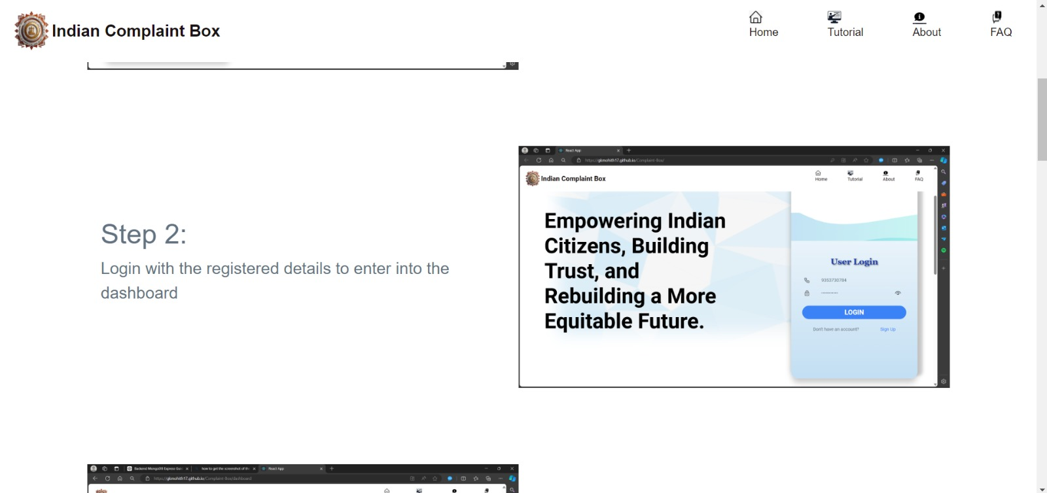

**4.FAQ Page:**

The FAQ Page is incorporated with the frequently asked questions by the users. This helps in preventing similar question to be asked repeatedly saving time of the users.

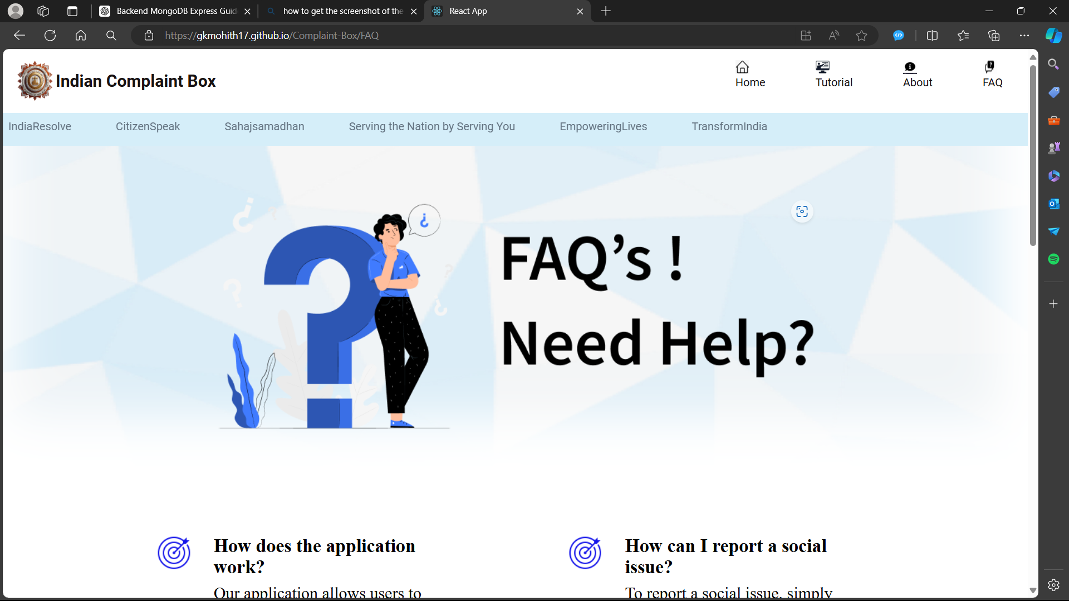

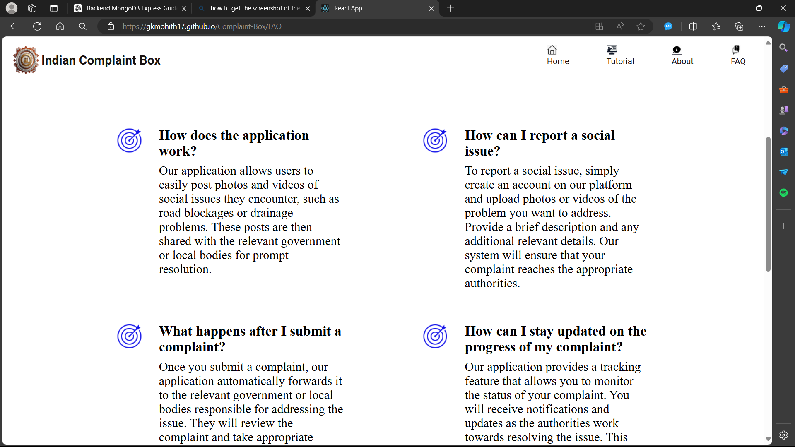

**5. The Dashboard:**

The dashboard contains the link to Lodge a complaint, to view the lodged complaint, to check the progress of the issue, and to give feedback.

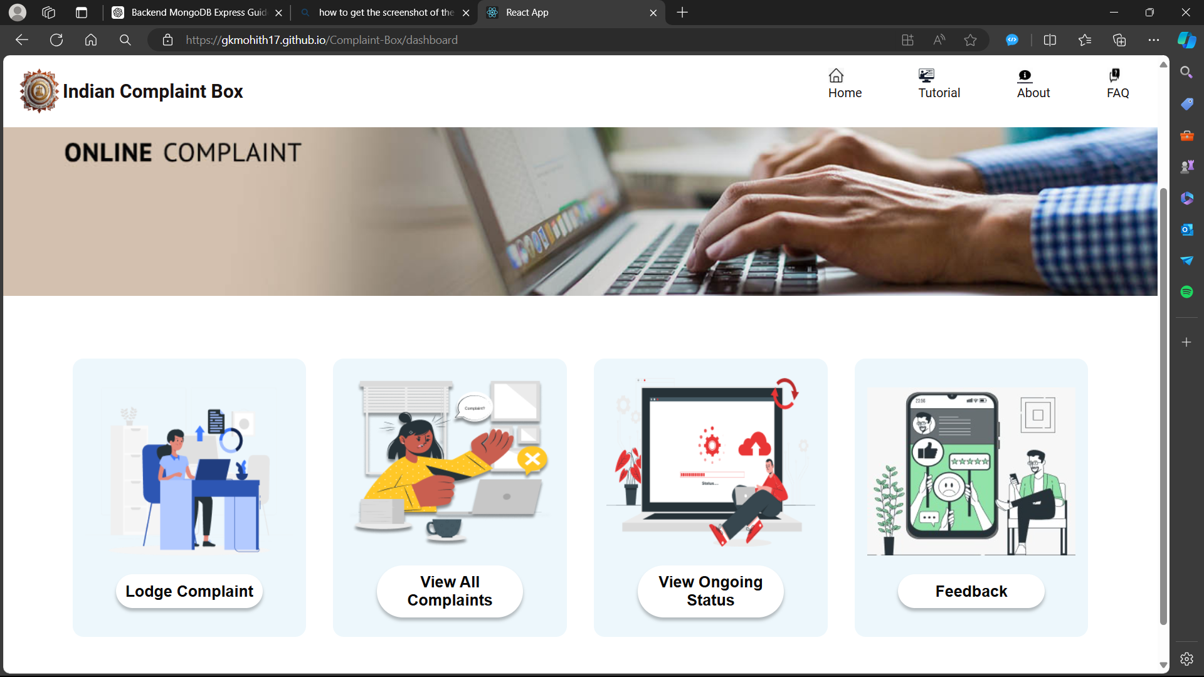

**6.Complaint Registration Page:**

The Lodge Complaint Page contains a form which accepts information about the nature of complaint, the state, district and pincode of the complaint’s location and proof of photos and videos.

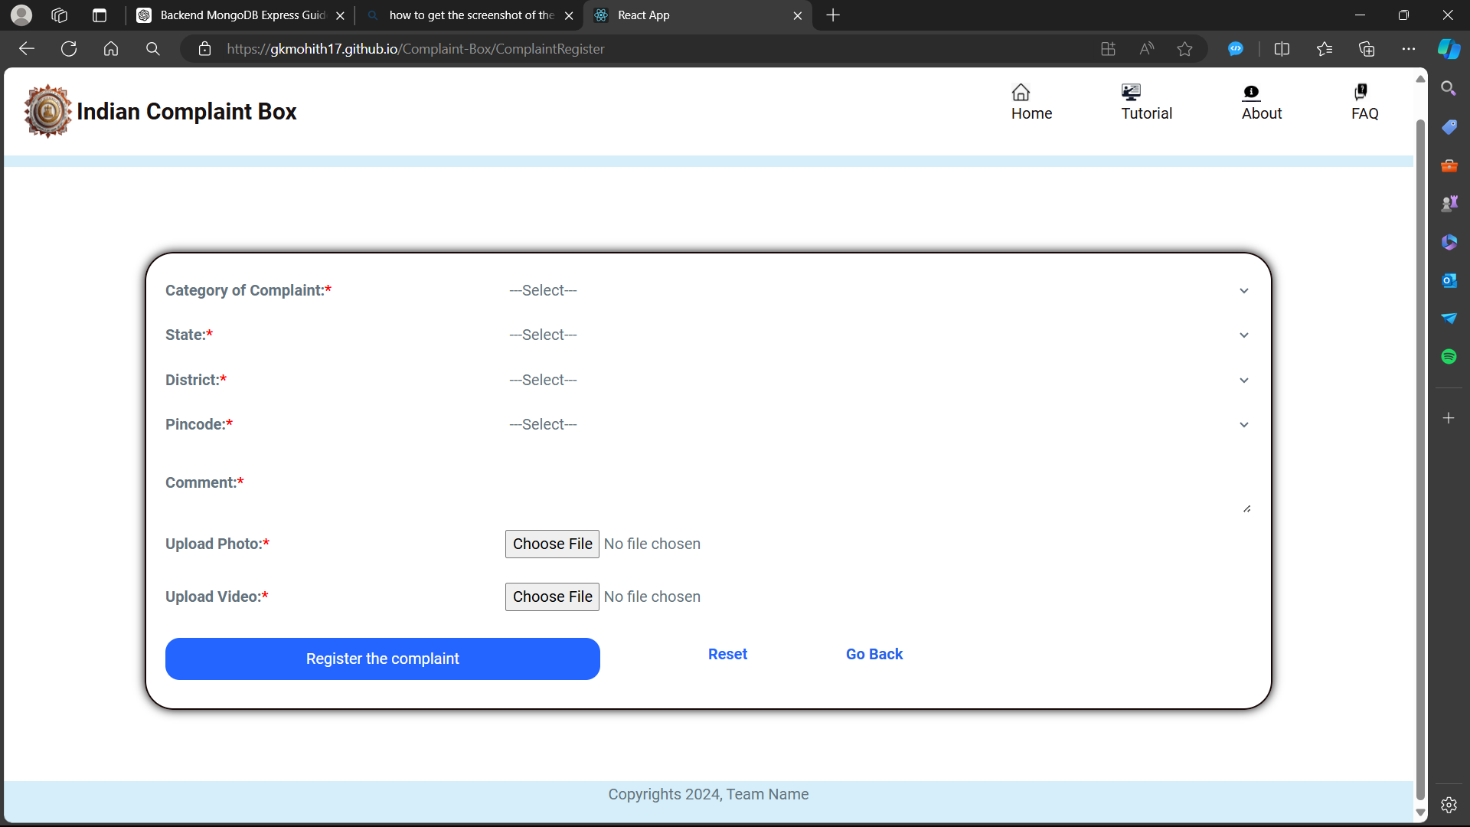

**7. Complaint Viewing Page:**

The complaint viewing page displays all the complaints registered by the users. It allows filtration of the complaints to view the required complaints.

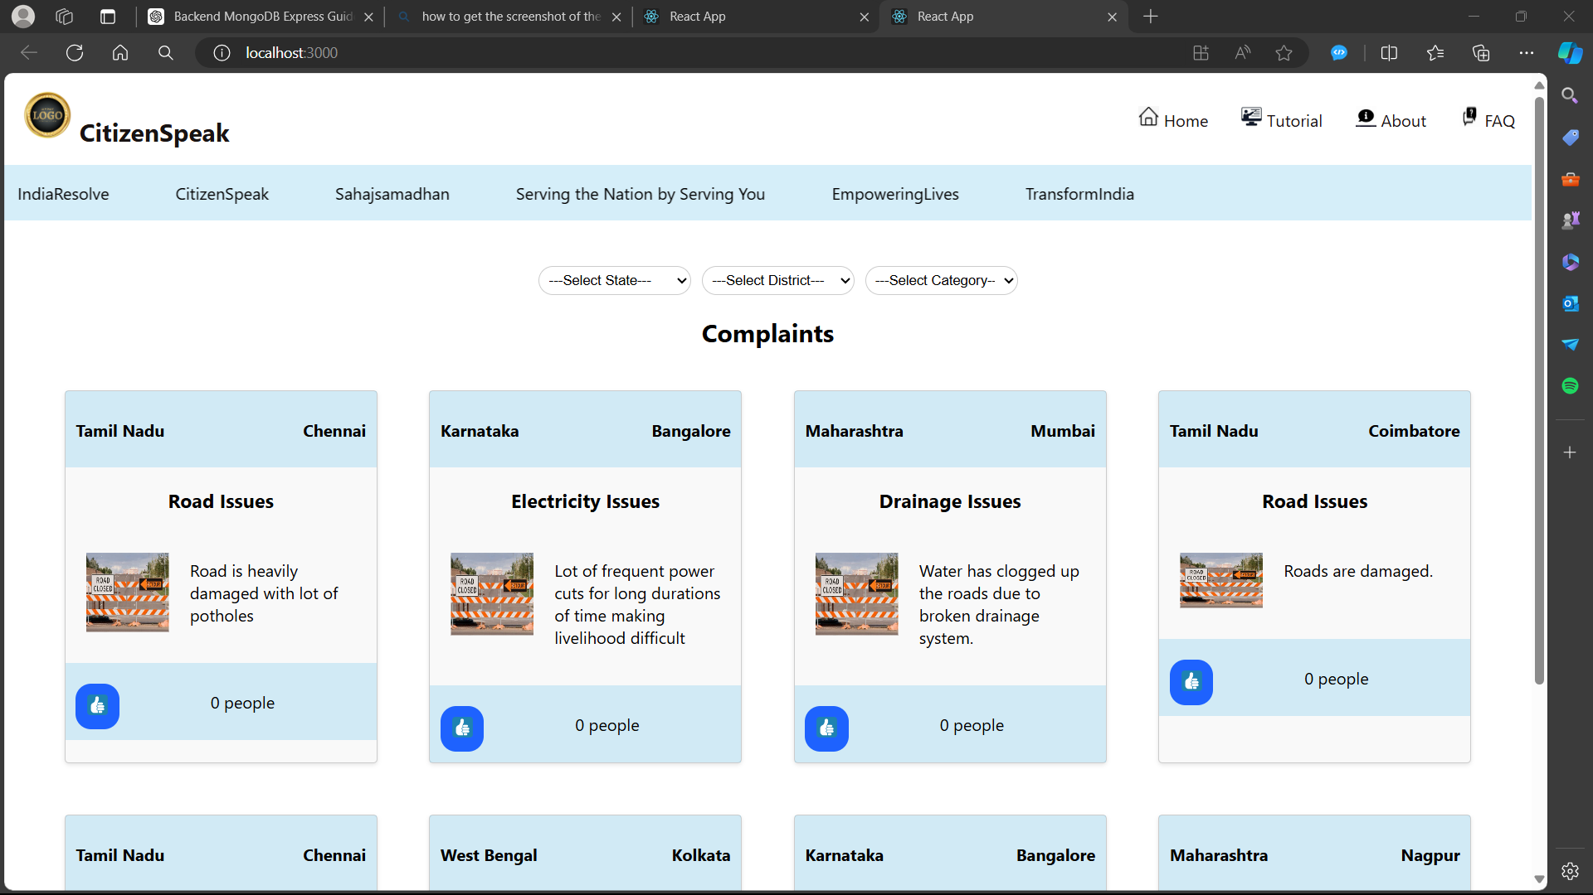

**8. Complaint Progress:**

Here the progress of the complaints can be tracked .

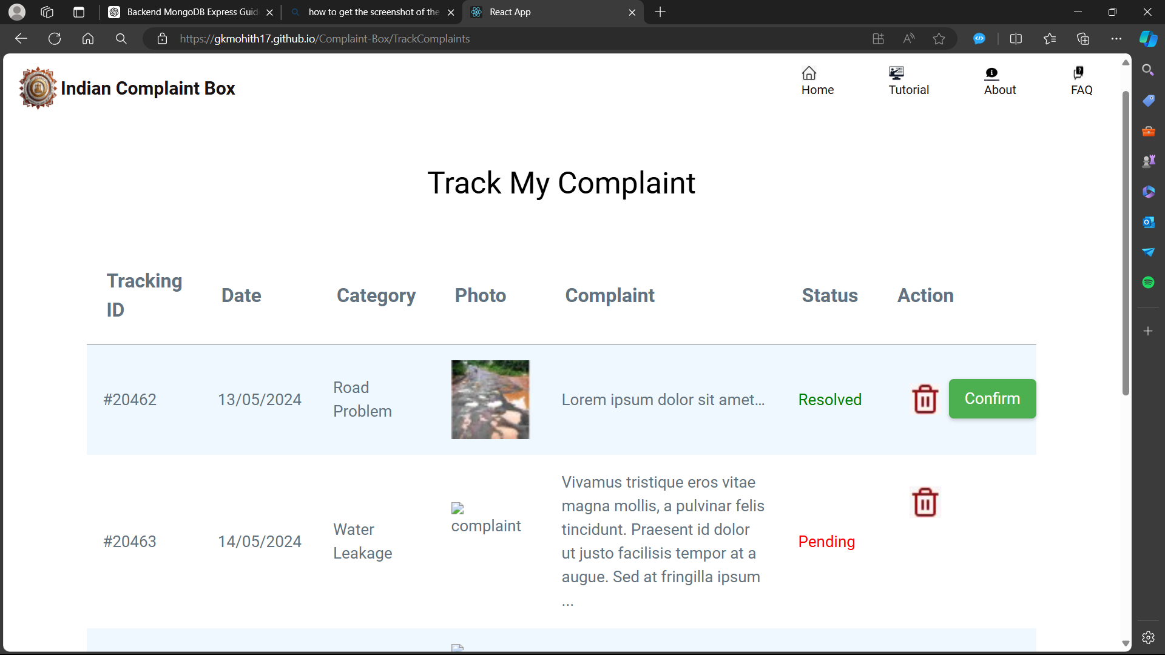

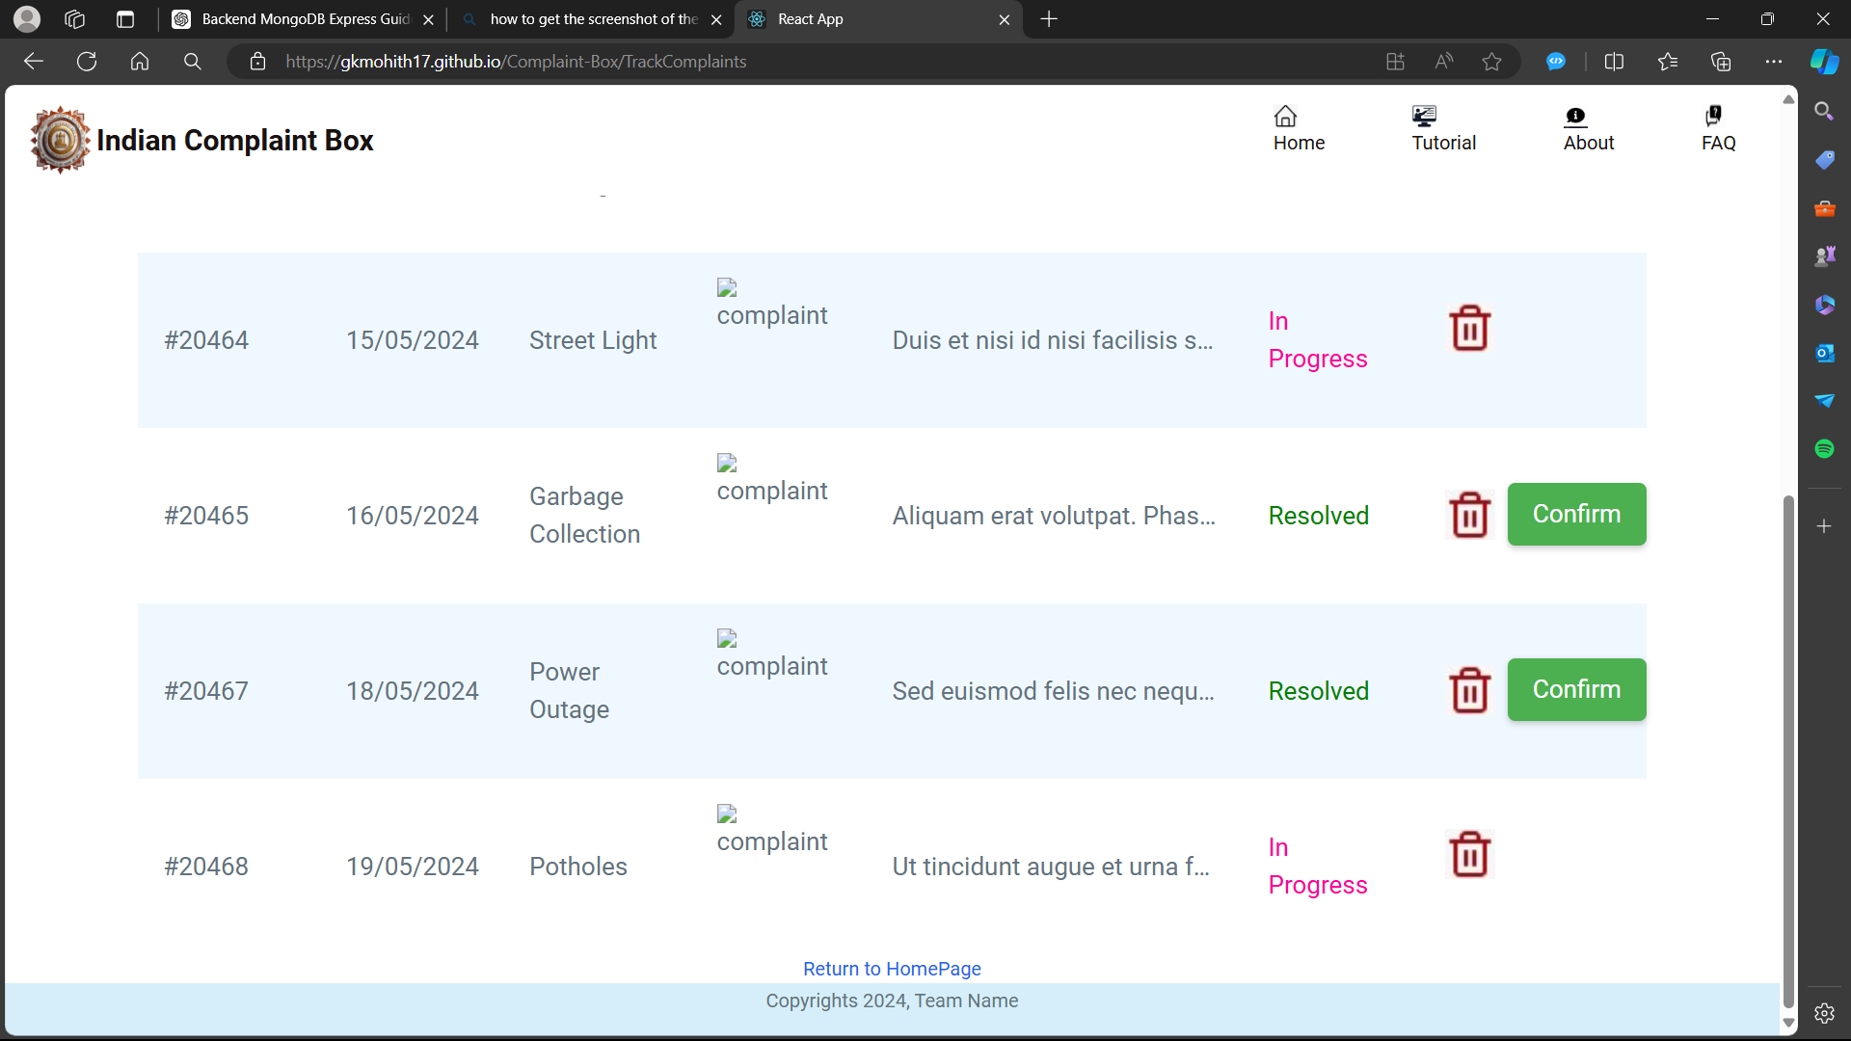

**9. Feedback Page:**

The users are at liberty to provide their feedbacks regarding the application and their grievances by filling in this form. The feedbacks are used to refine the application and helps in the betterment of the society.

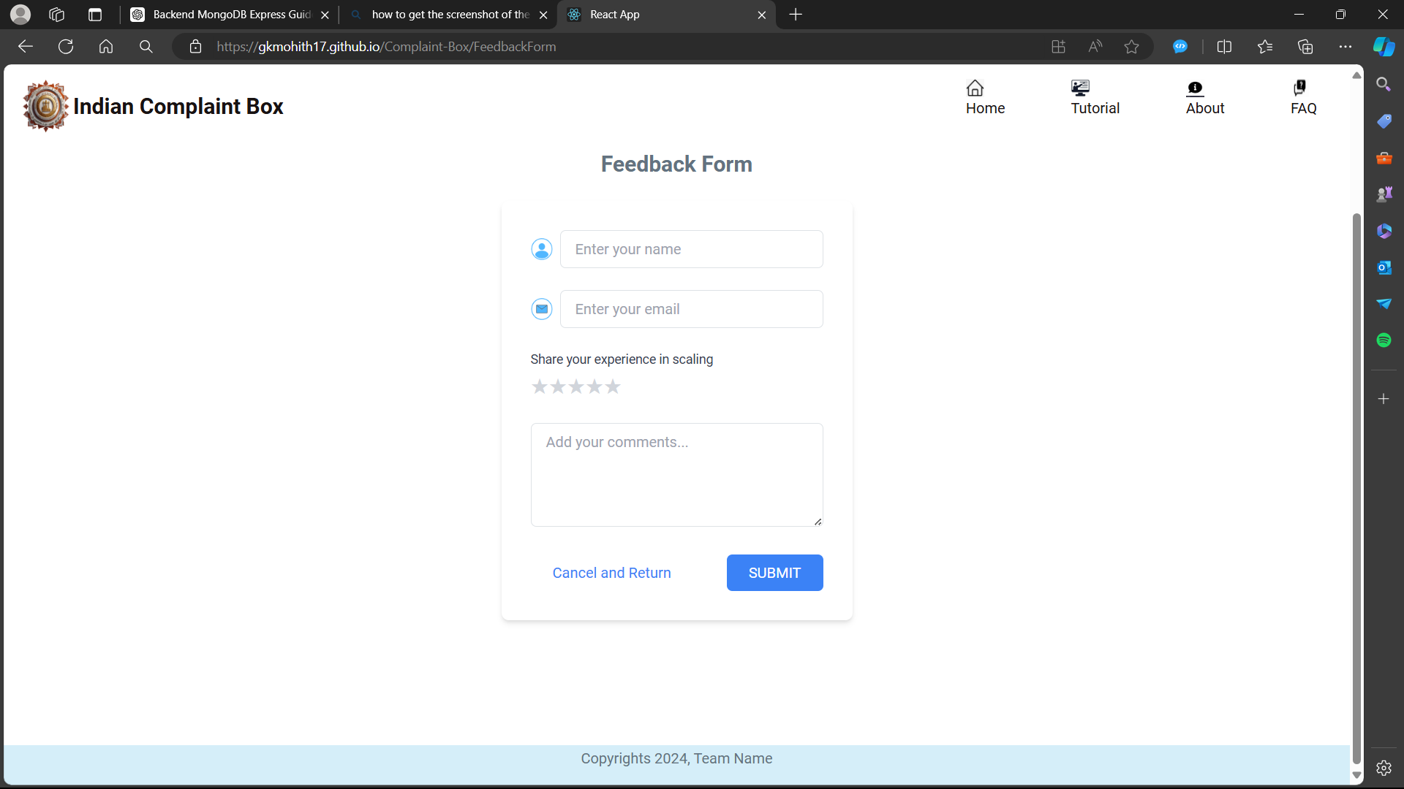

**10. Admin Login:**

Admin can login to the application using his login credentials for handling the application.

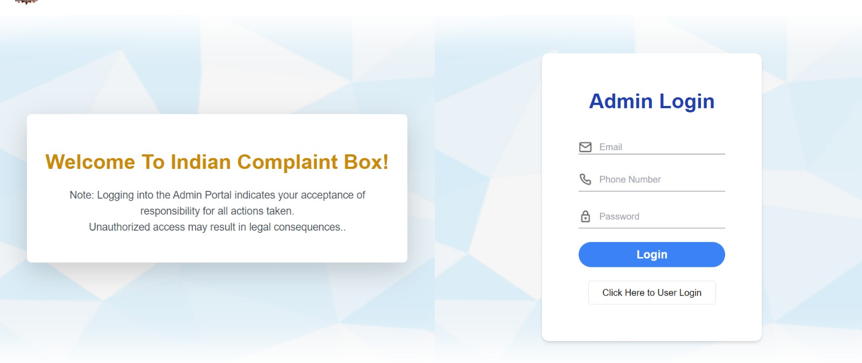

**11. Admin Dashboard:** Here the admin can view all the complaints registered by the users and can update the status of the complaint.

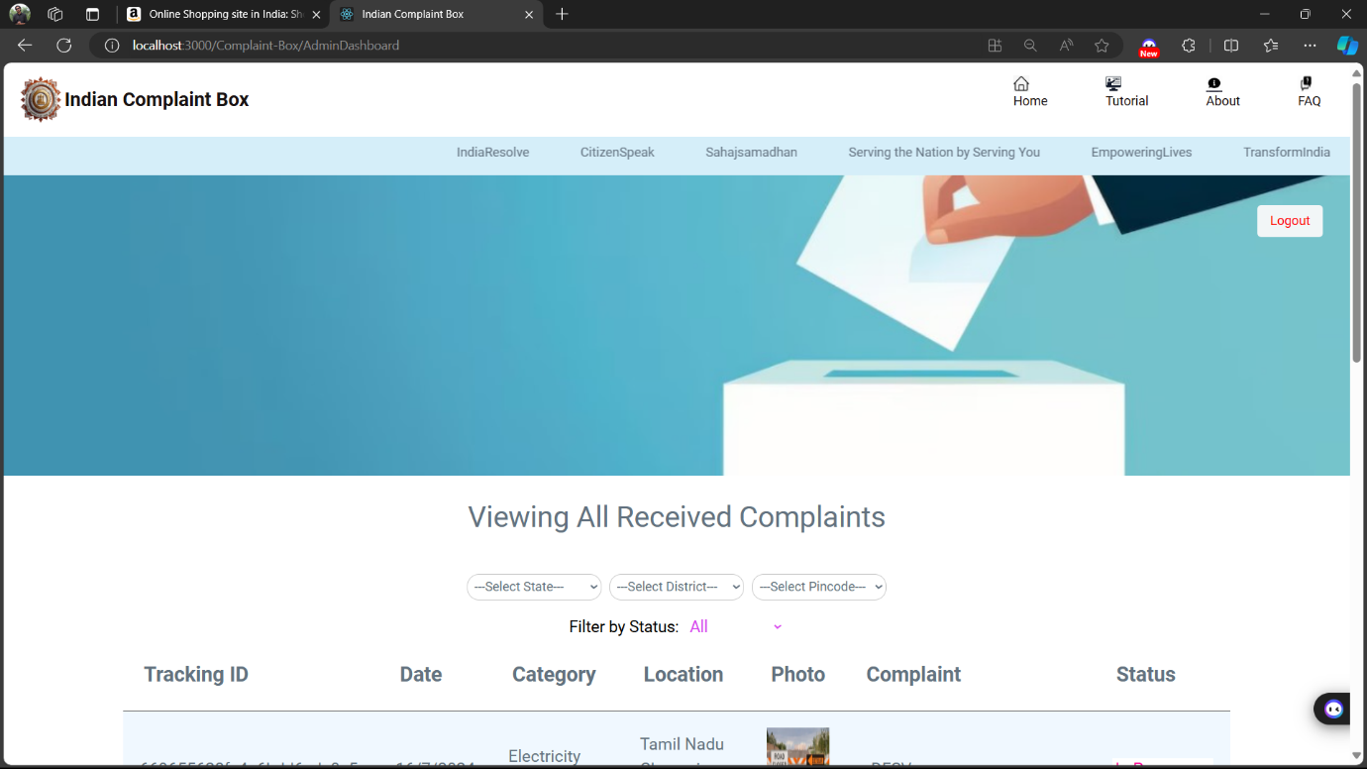

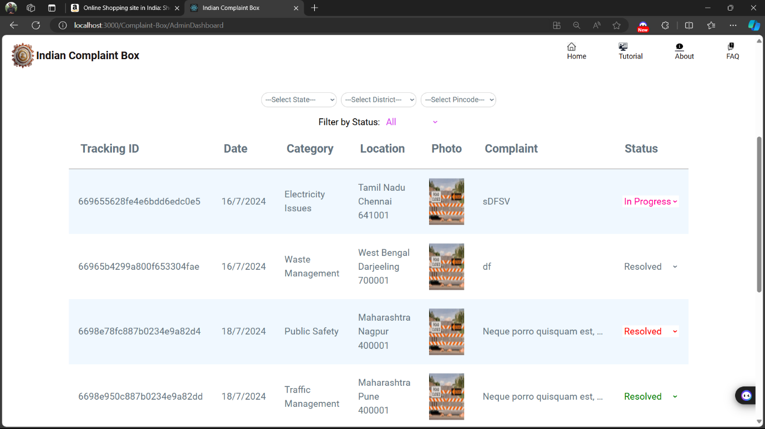

**Key Components**

1. **App.js**
   * Responsible for routing and main application layout.
2. **/components**
   * Contains reusable UI components used across the application.
   * It contains the Navbar and the footer components
3. **/pages**
   * Includes different pages for Web App.
   * It contains the Home page, About us page, Tutorial page, FAQ page.
   * It contains the dashboard
   * It includes the pages for dashboard like complaint registration, complaint viewing, complaint progress, and feedback

**Routing**

Routing is managed using React Router. Here are the main routes:

* **/home** - Landing page of the application.
* **/Tutorial**- Contains the instuctions on how to use the application
* **/About us**- Contains the information about the organization and its policy.
* **/FAQ**- Contains the frequently asked questions of the users.
* **/dashboard** - Dashboard displaying user data and statistics.
* **/Complaint Registration**- It includes the form to submit queries
* **/Complaint View**- Registered complaints can be viewed here
* **/Complaint Progress**- The progress of the complaint management is displayed.
* **/Feedback**- Takes feedback from users.

**Integration with Backend**

The frontend communicates with the backend APIs hosted on [backend URL]. Key endpoints include:

* **GET /api/complaints** - Retrieves all complaints for display.
* **POST /api/complaints** – Registers a new complaint
* **POST**/**api/user/login** -Handles user authentication
* **POST/api/user/register-** Registers a new user
* **GET/api/feedback-** Retrieves all feedback given by users.

**User Interface (UI) Design**

* The UI design follows a simplistic and light appearance theme to instill confidence about the Complaint resolvation.
* Design initially implemented using Figma application and then implemented and recreated using React.